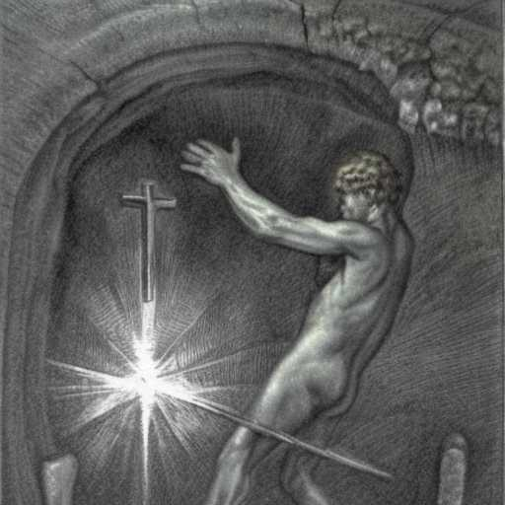
A CANDIDLY GRANDIOSE INTROSPECTION

To thine own self be true
I couldn't ever be anyone else but me
And he just did not t in anywhere

So I retired to a cave, where I became an expert on shadows
I found my way out and I wanted then to draw Mercury's path
to the Cross and beyond, so that I could give it all like some kind of John Baptist Bodhisattva

I was privileged by
societal rejection with an opportunity to live as a free soul

And I'm coming down the mountain now with my
answer to Zarathustra's challenge -
Gather the Spiritual Leaders, I say!

